**Pet Store API Automation using Karate Framework**

This automation suite is developed to automate the APIs mentioned in the following swagger file <https://petstore.swagger.io/>. For this automation karate utilities are used to call the APIs and the test execution reports are generated using cucumber reporting.

**How to get the code?**

1. The code is uploaded in the following GIT repository. User can clone the code and run it using java IDE like eclipse, intellij, etc.

<https://github.com/tpjohnmarshal/PetStoreAPIAutomationUsingKarate>

1. User can import the petStore.zip file into the IDE and run.

**What is the Framework Structure?**

1. All the required dependencies are provided in the pom.xml

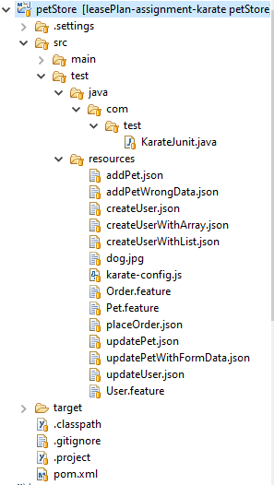

1. The src/test folder will contain the code and required resources (feature files)
2. Src/test/resources will contain 3 feature files named as Order.feature, Pet.feature and User.feature and the test steps for each scenario is written using BDD cucumber. This directory will also contain the required payloads in json format. During test execution the required pay load will be used by the framework automatically.
3. Src/test/java directory will contain the KarateJunit.java file, in which the required code to execute the test cases and generate the report.
4. The base URL and environment details are configured in karate-config.js file in resources directory.

**How to execute the code?**

1. Import the project into an IDE.
2. Provide the javac path in the pom.xml file.

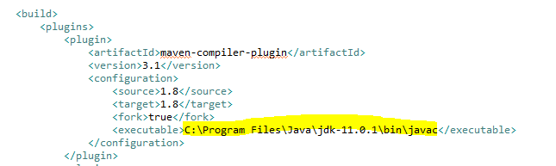

1. Verify all required dependencies(.jar files) are downloaded in the .m2 folder
2. Verify that NO compile errors in the code.
3. This framework will execute all the test cases marked with the tag **@regression.** Kindly make sure the required test cases are having the tag @regression in the respective feature files.
4. Right click on the project and select run Configurations.

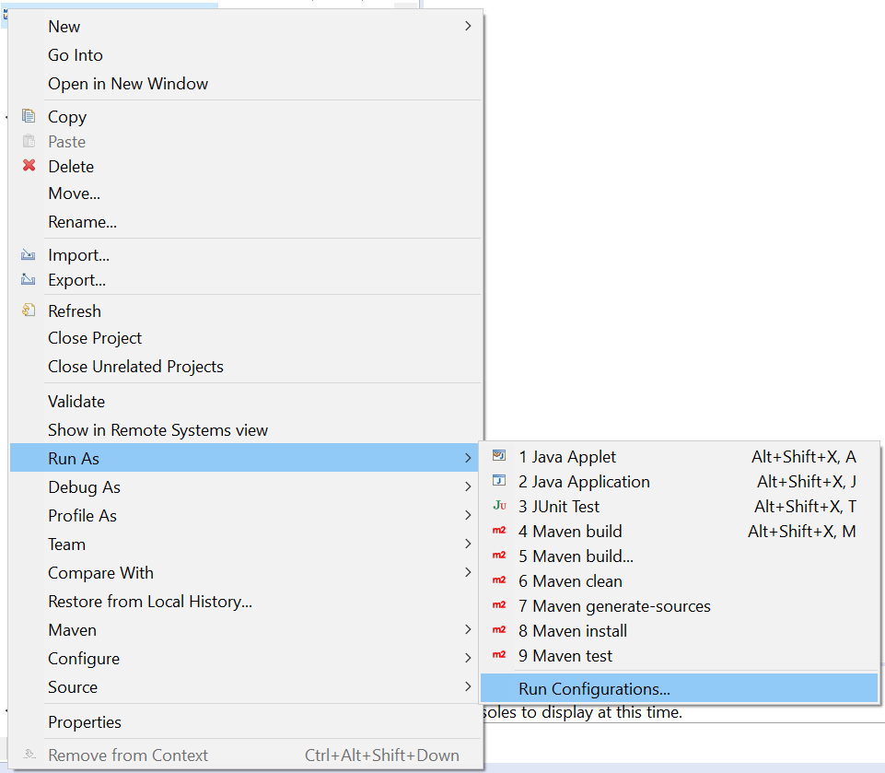

1. From the pop-up window right click on the Maven build and select New.

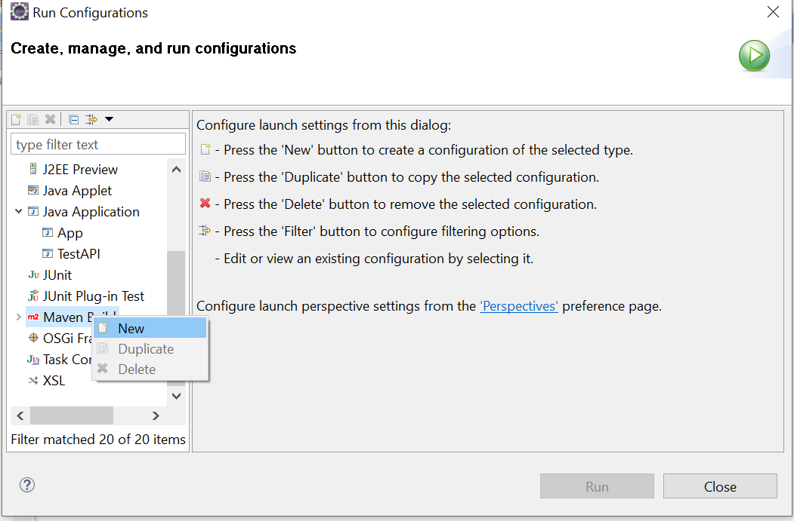

1. Provide a name for the configuration and select the project directory by click on the Browse Workspace button and select the root folder of PetStore project.

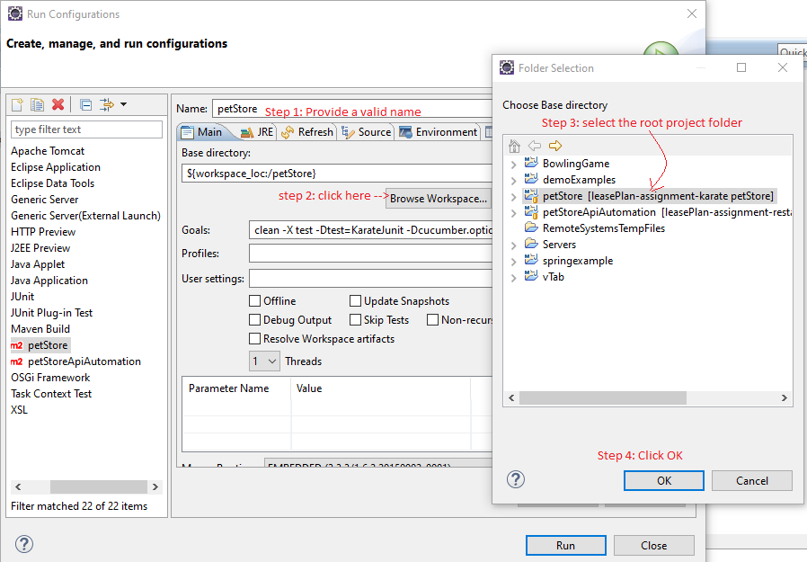

1. Provide the following test goal in the **Goals** field and click on **Apply** Button.

**clean -X test -Dtest=KarateJunit -Dcucumber.options="--tags @regression" -DargLine='-Dkarate.env=PR'**

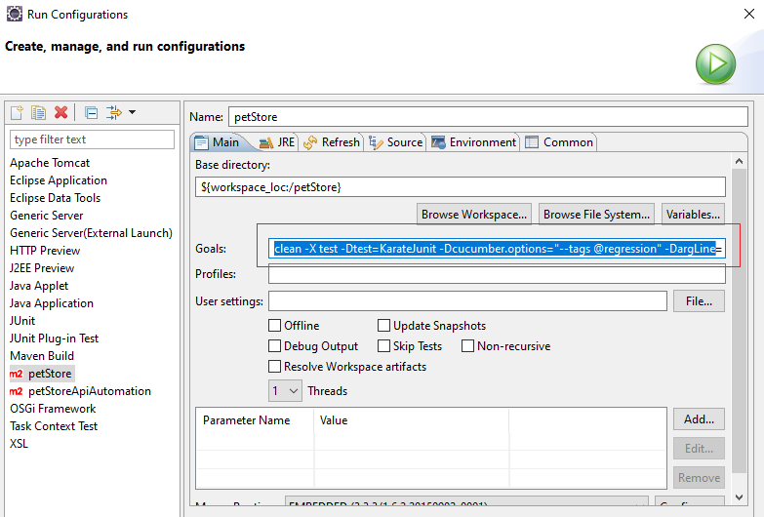

1. Click on the **Run** button to execute the project. Once all the test scenarios with @regression tag are executed, the user can see **Build Success**  in the console window. In case of failure in any of the test steps then **Build Failure** will be displayed in the console.

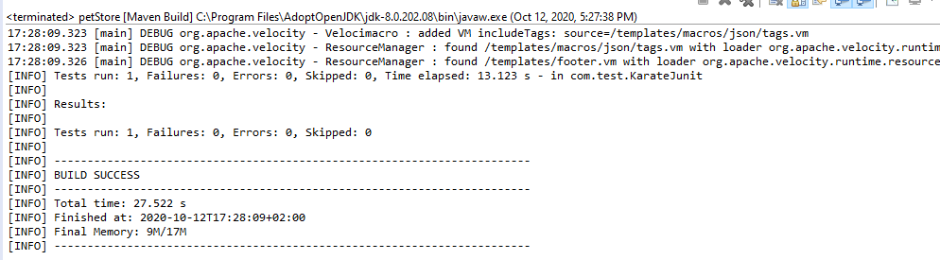

1. Both the cases the test report will be generated inside the target directory. HTML reports can be seen under cucumber-html-reports.

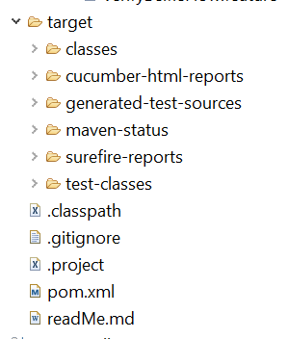

**How to add a new test case?**

1. Open the respective feature file and add a new scenario.
2. If required provide a valid tag for the feature file
3. If new tags are added, then add the new tag value in the Maven Build goal and execute the framework.